HDD2023 POSTER or TALK ### – DO NOT EDIT
Your Title in Title Case and Ideally a Single Line
Presenter Underlined¹, Firstname Surname^{1,2}, Firstname Surname^{1,3}
¹ School or Department or Institute, University of Somewhere, Country; ² Keep Affiliations Short, No Need for Postcodes, Street Addresses; ³ Affiliations in italics and separate with a semicolon not new lines
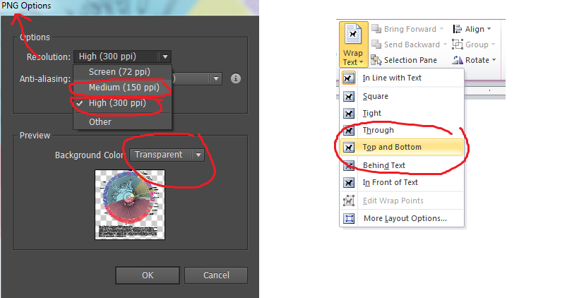Put your abstract here. Do not justify the text. Leave it centred with ragged ends. Keep your abstract on a single page. There is no need to include contact details. We will have that somewhere else. A single graphic is OK, but no caption. The graphic must be 300 dpi and at the size it needs to be and ideally a PNG. Make it centred. No reference lists. No hyperlinks. If you must refer to a published work, please cite the DOI in the text in the shortest form that is possible e.g. “In recent work by Jones et al. (DOI: 10.1021/acschembio.9b00167)”. Keep the abstract text short and sweet! Consider the audience will be a range of people from chemists, protein biochemists and industry scientists so try to write an abstract that reaches all the audience. Put the graphic at the bottom. Please don’t change the margins and don’t let the image go over the margins. We will add a page number at the bottom. Please do not alter paragraph spacing. Thank you! E-mail your abstract to josh.mylne@curtin.edu.au

